**WEEK 1: CREATION OF INVENTORY, MANUFACTURING TABLE, SUPPLIER TABLE, SUPPLY CHAIN TABLE FROM THE ORIGINAL SUPPLY CHAIN PERFORMANCE DATASET**

1. **Creating Inventory table:**

Fields/column requirements:

1.Product type

2.SKU

3.Availibility

4.Number of products sold

5.customer demographics

6.stock levels

7.lead times

8.order quantities

9.lead time

10.Revenue generated

Steps:

1. Create a duplicate of the supply chain performance dataset.
2. Rename it as Inventory.
3. Transform the Inventory table by removing the unnecessary columns from it by taking the help of the column field requirements.
4. Now, the Inventory table has met the requirements of the column fields and looks like:

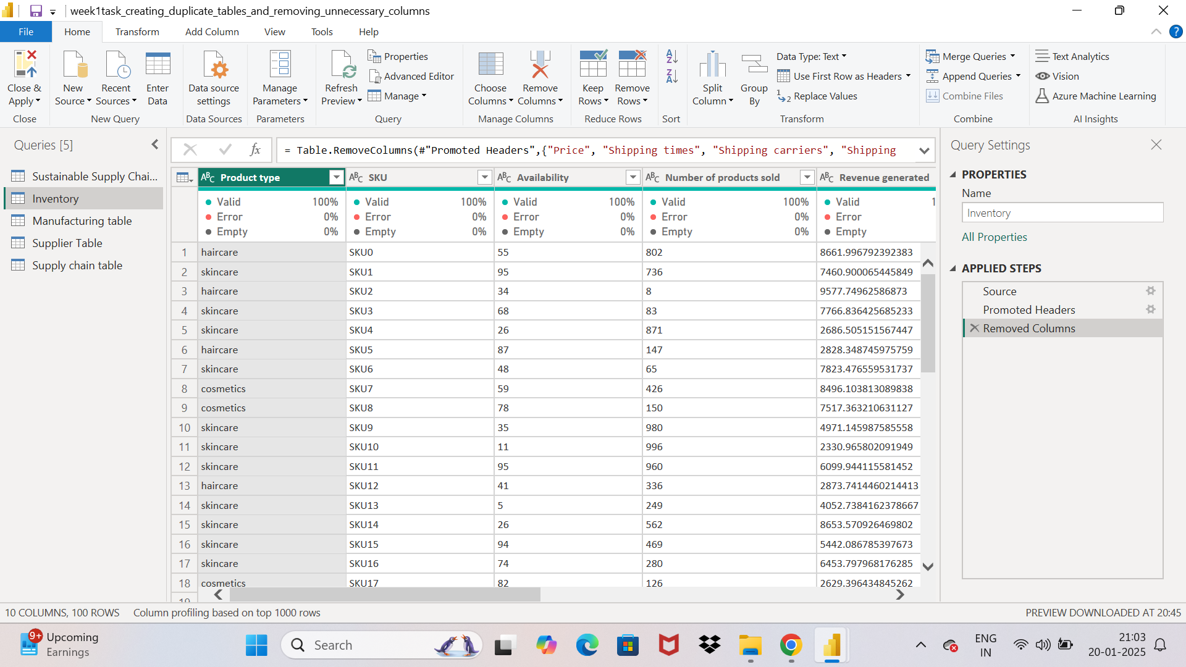

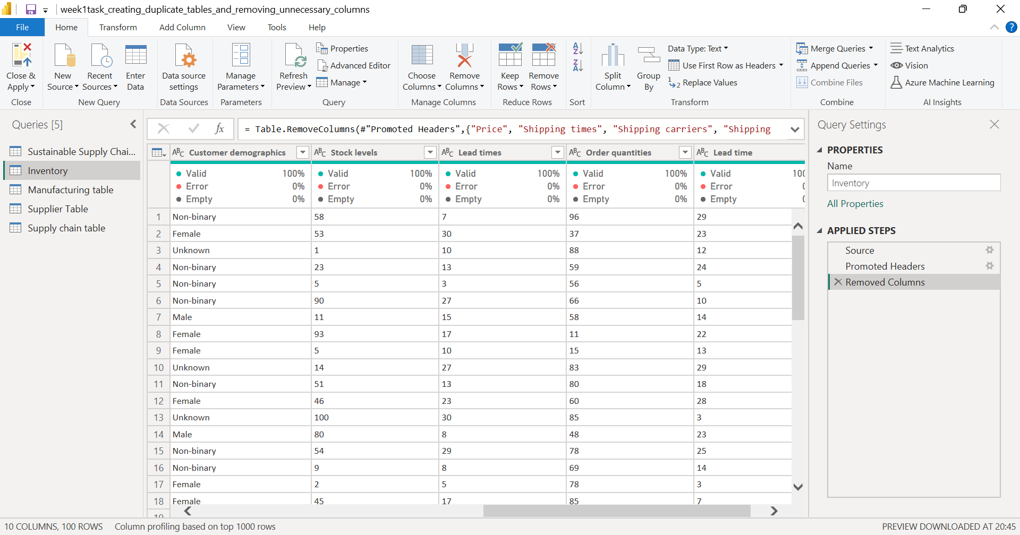

1. **Creating Manufacturing Table:**

Column field Requirements:

1. Product type
2. SKU
3. Production volumes
4. Manufacturing lead time
5. Manufacturing costs
6. Inspection results
7. Defect rates

Steps:

1. Create a duplicate of the supply chain performance dataset.
2. Rename it as Manufacturing table.
3. Transform the Manufacturing table by removing the unnecessary columns from it by taking the help of the column field requirements.
4. Now, the Manufacturing table has met the requirements of the column fields and looks like:

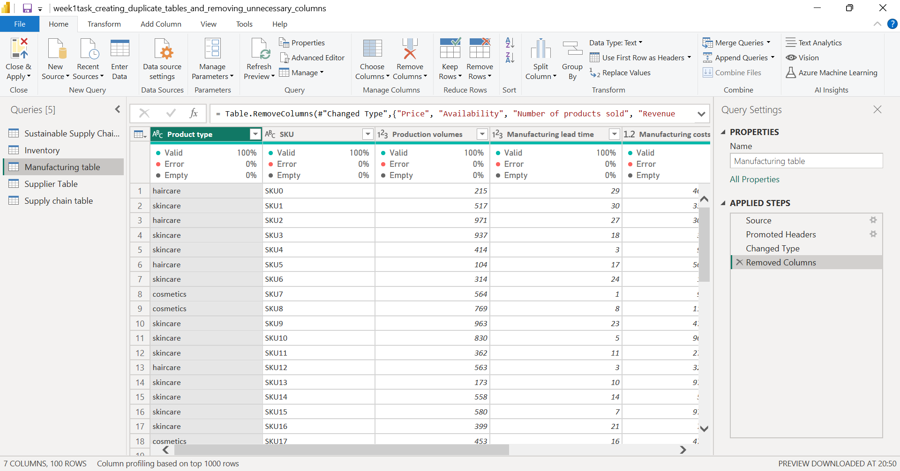

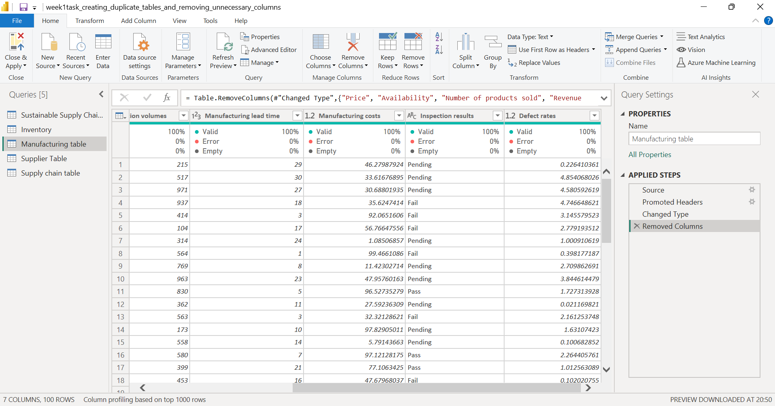

1. **Creating Supplier table:**

Column requirements:

1. Supplier name
2. Location
3. Lead time
4. Transportation modes
5. Routes

Steps:

1. Create a duplicate of the supply chain performance dataset.
2. Rename it as Supplier table.
3. Transform the Supplier table by removing the unnecessary columns from it by taking the help of the column field requirements.
4. Now, the Supplier table has met the requirements of the column fields and looks like:

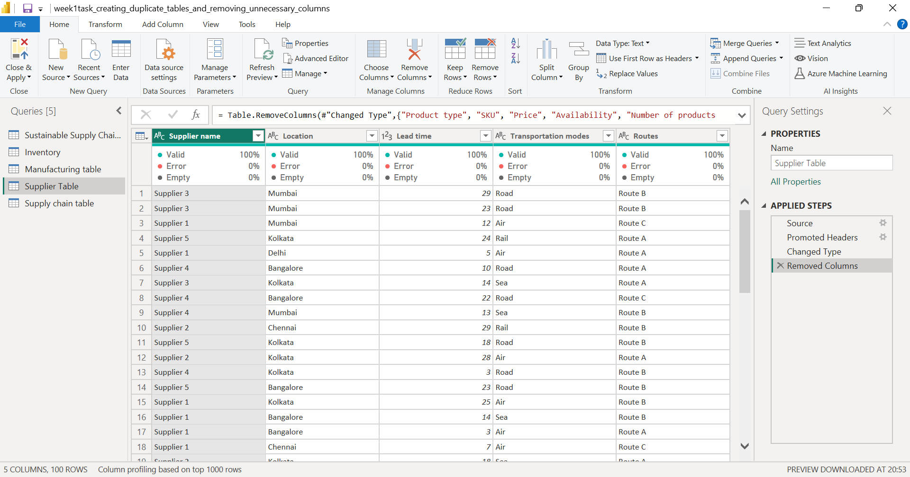

1. **Creating supply chain table:**

Column field requirements:

1. Product type
2. SKU
3. Price
4. Availability
5. Number of products sold
6. Revenue generated
7. Customer demographics
8. Stock levels
9. Lead times
10. Order quantities
11. Shipping times
12. Shipping carriers
13. Shipping costs
14. Supplier name
15. Location
16. Lead time
17. Transportation modes
18. Routes

Steps:

1. Create a duplicate of the supply chain performance dataset.
2. Rename it as supply chain table.
3. Transform the supply chain table by removing the unnecessary columns from it by taking the help of the column field requirements.
4. Now, the supply chain table has met the requirements of the column fields and looks like:



